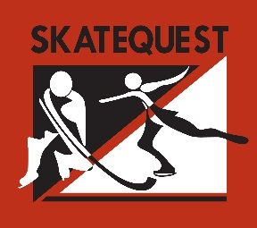

Phase 3 Guidelines
General Guidelines
Temporary exits will remain in place throughout this phase. Prior to visiting, please take note of which rink your event is scheduled.
Doors to the facility will remain closed until 10 minutes prior to the start of an activity.
All individuals entering the facility will be required to use hand sanitizer and undergo a health screening before entering the facility, including having their temperature measured by a no contact thermometer. Individuals who are symptomatic will not be permitted access to the facility.
Face coverings are mandatory in the facility. They may be removed when on the ice.
One (1) parent/guardian per family may accompany their skater(s) into the building (this includes coaches, team managers, scorekeepers, team photographers, etc.). Siblings and other spectators are not permitted. We request parents/guardians entering the building remain in the building until their skater has completed their session. If you choose to leave, we reserve the right to refuse reentry.
Skaters must arrive ready to skate and may only enter the building 10 minutes before their scheduled program start-time. Tents are set-up outside each entrance. Because of the number of people coming and going, tents should be used to tie skates, not dress. Masks must be worn by both players and parents when in the tent. Bags and shoes may not be left as the tents are continuously being sued.
Bags are not permitted in the facility.
Upon the conclusion of an activity, skaters have 10 minutes to leave the facility. Please exit at the time and path designated so we can minimize contact between customers.
Benches and bleachers are all marked with a blue “X” to ensure proper social distancing procedures.
Water fountains, vending and arcade machines are off-limits.
The health and safety of our customers and staff remains our top priority. As we allow more customers to enter the building, we will continue to keep SkateQuest the cleanest facility in the area.

Thank you for your continued support!

